Q1.
Answer is B.

A:WHERE cannot be used with aggregate functions like COUNT(*). Use HAVING instead.
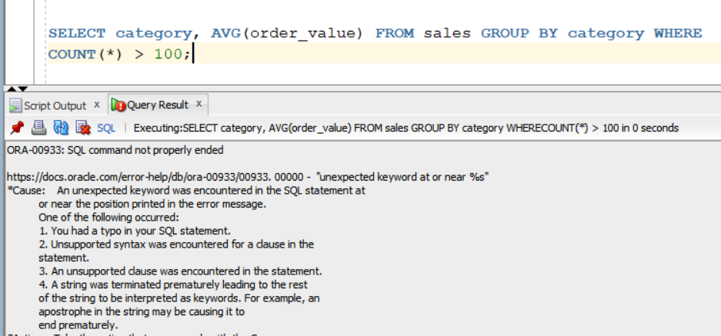

B:This groups the sales by category, calculates the average order value, and filters out categories with 100 or fewer orders.
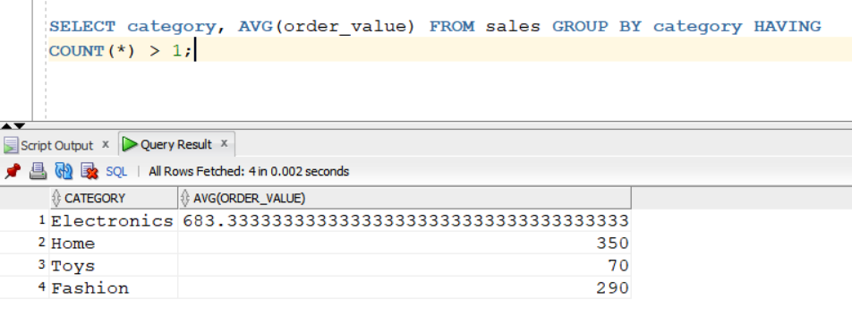

C: COUNT(*) is an aggregate, and you can't use it in WHERE
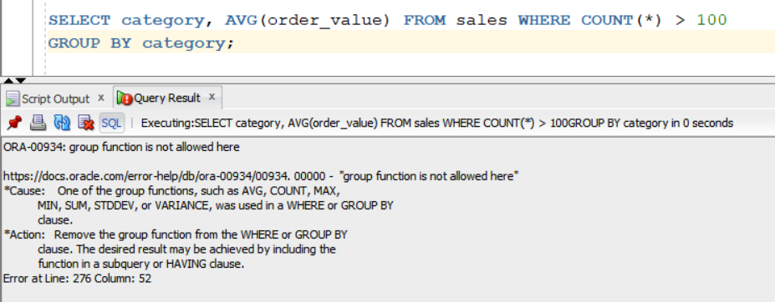
D: also work in oracle 12c but less protable
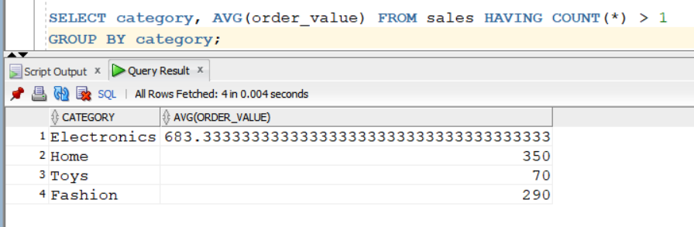

Q2.
Answer is A.
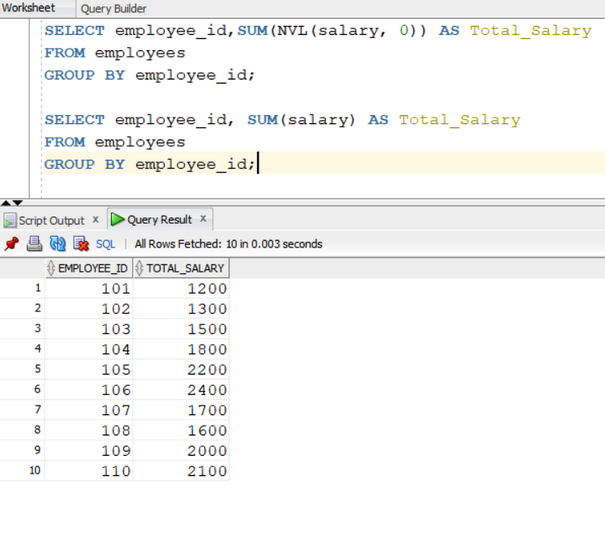
A: Adds up all non-NULL sales values.

B: Invalid.TOTAL() is not recognized in SQL function.

C: Replaces NULL with 0 before summing.

D: AGGREGATE() is not a recognized SQL function.

Q3.
Answer is A.

A:
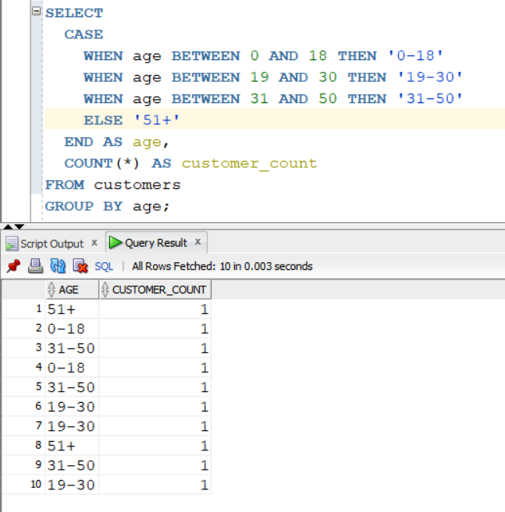

B: Not suitable for grouping and counting across multiple age ranges.

C: Not suitable for defining age ranges.

D: Not ideal for simple grouping by age ranges.

Q4.
Answer is D.

D:
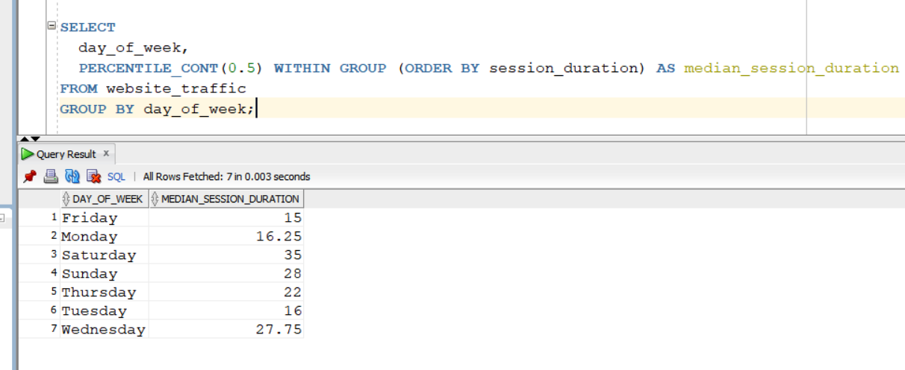

A: Not suitable — returns mean, not median.

B: it's not standard SQL and not widely supported

C: Invalid — doesn't exist in SQL.

Q5.
Answer is A.

A:
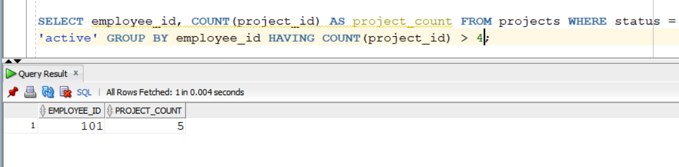

B:Invalid syntax
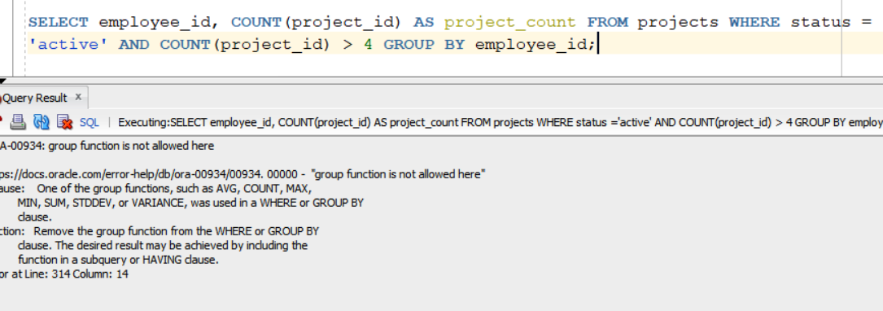

C:Invalid logic
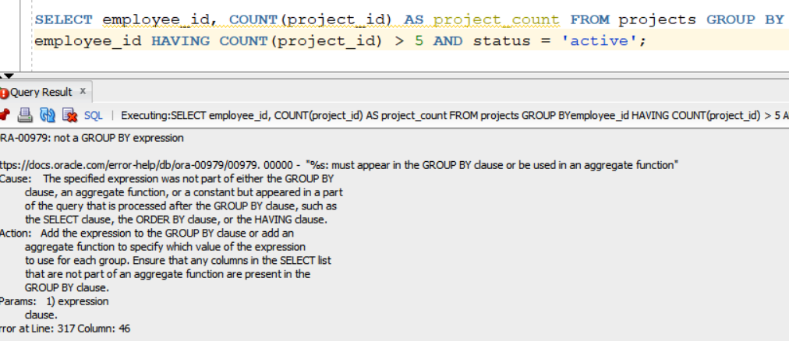

D: Potentially invalid.
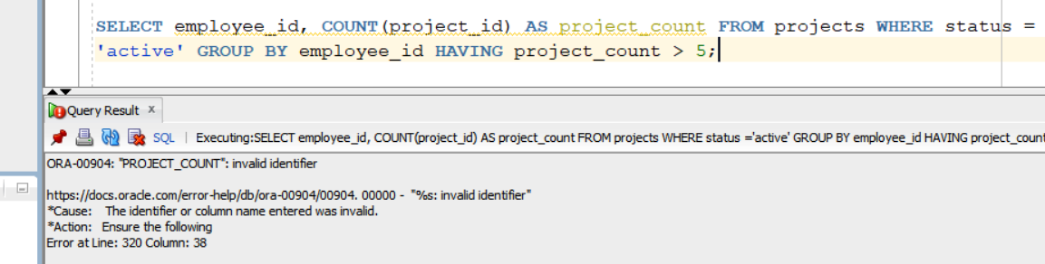

Q6.
Answer is A.

A:
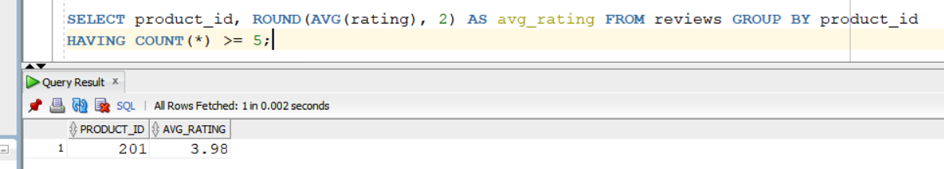

B: Technically valid, but less accurate
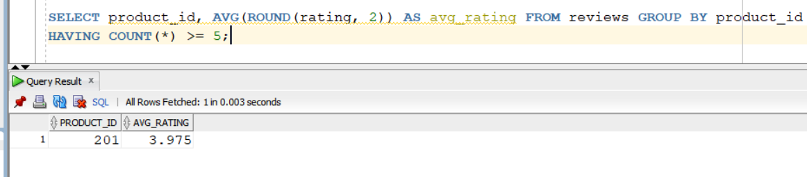

C: Invalid syntax.
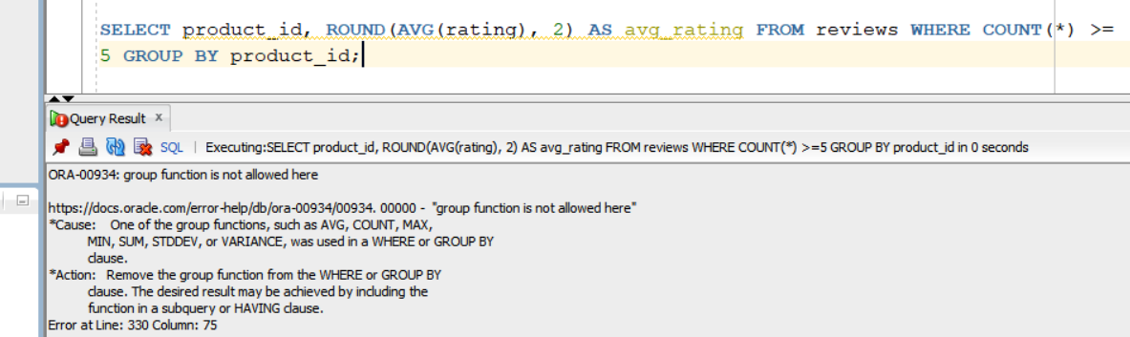

D:Invalid syntax.
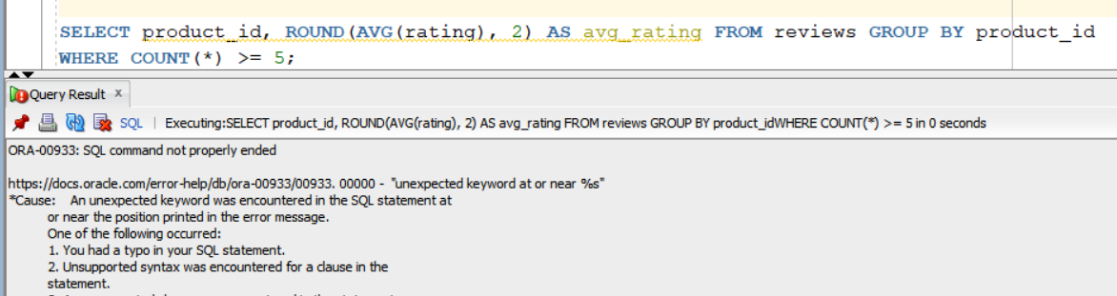

Q7.
Answer is C.

A: in Oracle 12c, the LIMIT clause is not supported.
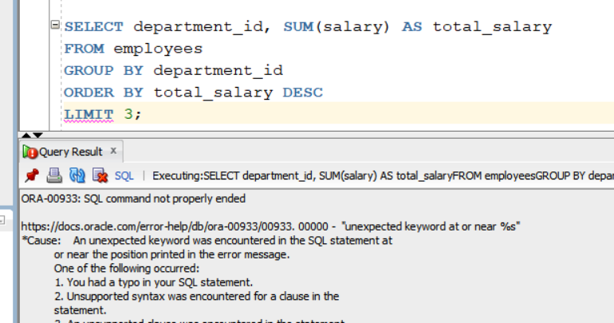

B:Valid only in SQL Server
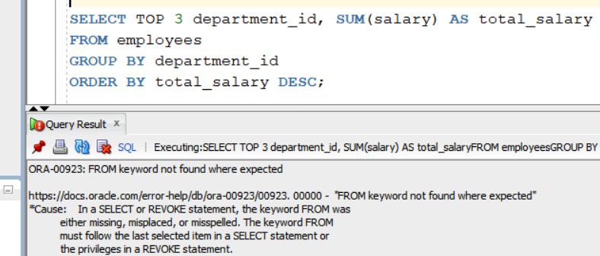

C: Correct in Oracle 12c.
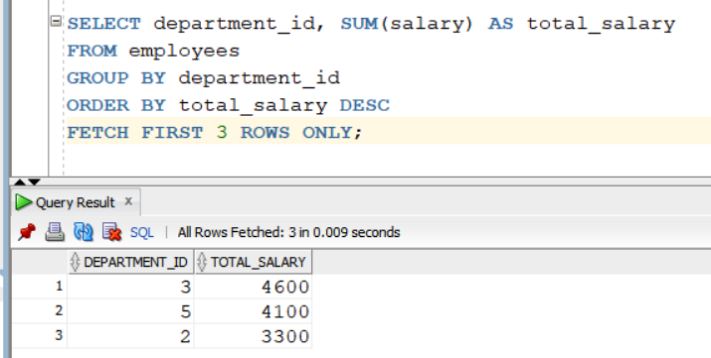

D: Can produce wrong results
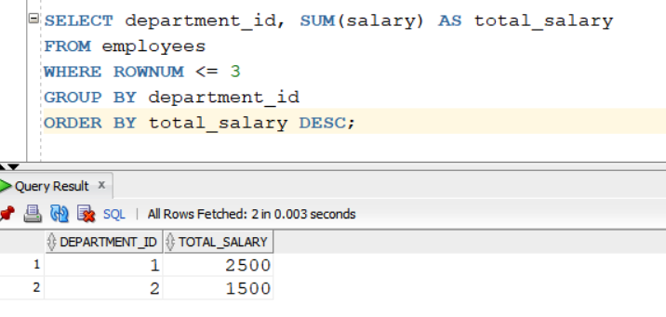

Q8.
Answer is C.

A:No ordering or running total — just one row per product.
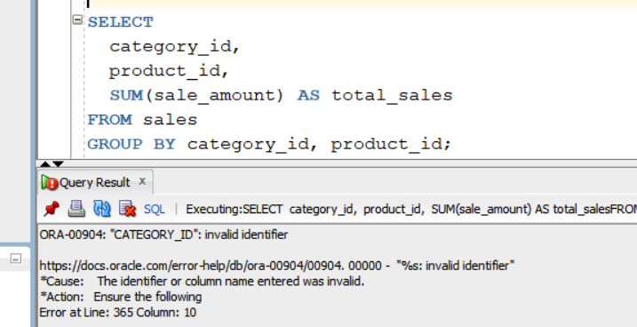

B:Syntax error — missing OVER clause.
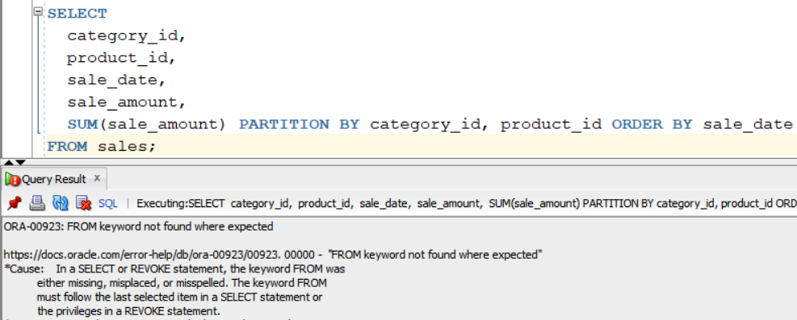

C: Correct one.
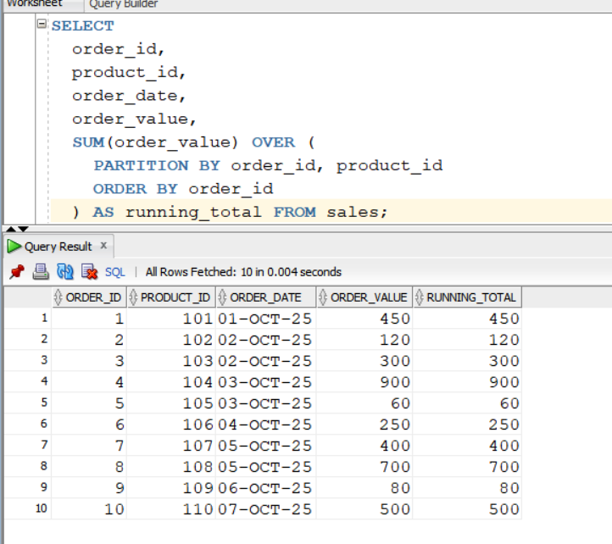

D: Useful for summary reports, not for time-based running totals.
